|  |  |
| --- | --- |
| **EXP : 7** | **COOKIE TO STORE USER INFORMATION** |

**AIM:**

Write a Servlet program to  
store a user's preferences (like theme or language) using cookies. Retrieve and  
display these preferences on subsequent visits.

**CODE:**

**Cookie.html:**

<!DOCTYPE html>

<html>

<head>

<meta charset=*"UTF-8"*>

<title>COOKIE</title>

</head>

<body>

<form action=*"//aishu//cookie"* method=*"post"* >

<label for=*"name"* >USER-NAME</label>

<input type=*"text"* name=*username* placeholder=*"Enter the User-name"* required>

<br>

<br>

<label for=*"password"*>PASSWORD

</label>

<input type=*"text"* name=*password* placeholder=*"Enter the Password"* required>

<br>

<input type = *"submit"* value= *"signin"*>

</form>

</body>

</html>

**Cookie.java:**

package com.aishu.servlet;

import java.io.IOException;

import javax.servlet.ServletException;

import javax.servlet.annotation.WebServlet;

import javax.servlet.http.Cookie;

import javax.servlet.http.HttpServlet;

import javax.servlet.http.HttpServletRequest;

import javax.servlet.http.HttpServletResponse;

/**

* Servlet implementation class cookie

*/

@WebServlet("/cookie")

public class cookie extends HttpServlet {

private static final long serialVersionUID = 1L;

/**

* @see HttpServlet#HttpServlet()

*/

public cookie() {

super();

// TODO Auto-generated constructor stub

}

/**

* @see HttpServlet#doGet(HttpServletRequest request, HttpServletResponse response)

*/

protected void doGet(HttpServletRequest request, HttpServletResponse response) throws ServletException, IOException {

// TODO Auto-generated method stub

response.getWriter().append("Served at: ").append(request.getContextPath());

}

/**

* @see HttpServlet#doPost(HttpServletRequest request, HttpServletResponse response)

*/

protected void doPost(HttpServletRequest request, HttpServletResponse response) throws ServletException, IOException {

String user = request.getParameter("username");

String pass = request.getParameter("password");

if(user.equals("123") && pass.equals("123") ){

Cookie username = new Cookie("username", user);

username.setMaxAge(60*60);

username.setPath("/");

response.addCookie(username);

response.sendRedirect(request.getContextPath() + "/getcookie");

}

}

}

**GetCookie.java:**

package com.aishu.servlet;

import java.io.IOException;

import java.io.PrintWriter;

import javax.servlet.ServletException;

import javax.servlet.annotation.WebServlet;

import javax.servlet.http.Cookie;

import javax.servlet.http.HttpServlet;

import javax.servlet.http.HttpServletRequest;

import javax.servlet.http.HttpServletResponse;

/**

* Servlet implementation class getcookie

*/

@WebServlet("/getcookie")

public class getcookie extends HttpServlet {

private static final long serialVersionUID = 1L;

private static final PrintWriter NULL = null;

/**

* @see HttpServlet#HttpServlet()

*/

public getcookie() {

super();

// TODO Auto-generated constructor stub

}

/**

* @see HttpServlet#doGet(HttpServletRequest request, HttpServletResponse response)

*/

protected void doGet(HttpServletRequest request, HttpServletResponse response) throws ServletException, IOException {

Cookie[] cookies = request.getCookies();

String cookieName = "username";

if (cookies != null) {

for (Cookie cookie : cookies) {

if (cookieName.equals(cookie.getName())) {

System.out.println("username "+cookie.getName());

PrintWriter out = response.getWriter();

out.println(cookie.getValue());

}

}

}

}

/**

* @see HttpServlet#doPost(HttpServletRequest request, HttpServletResponse response)

*/

protected void doPost(HttpServletRequest request, HttpServletResponse response) throws ServletException, IOException {

// TODO Auto-generated method stub

doGet(request, response);

}

}

**OUTPUT:**

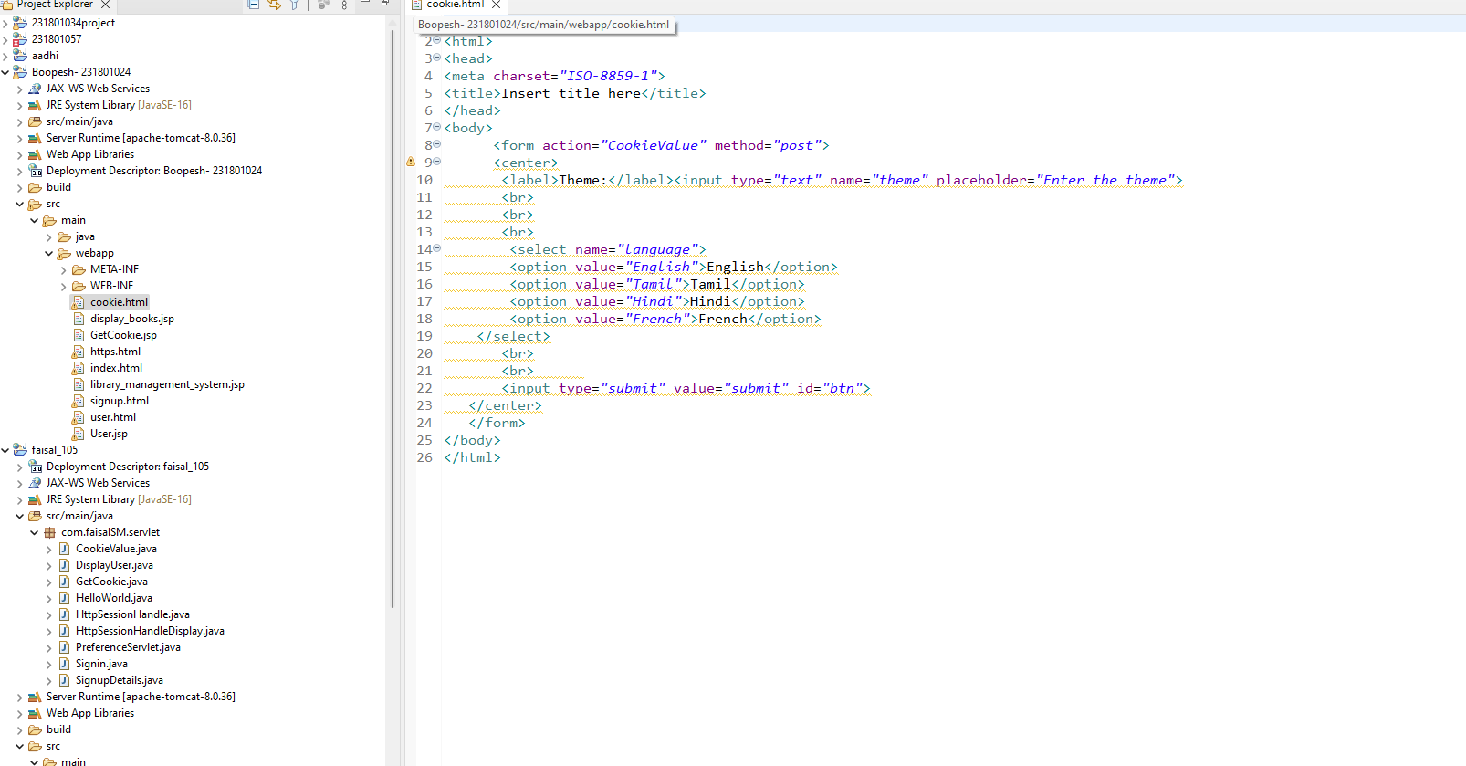

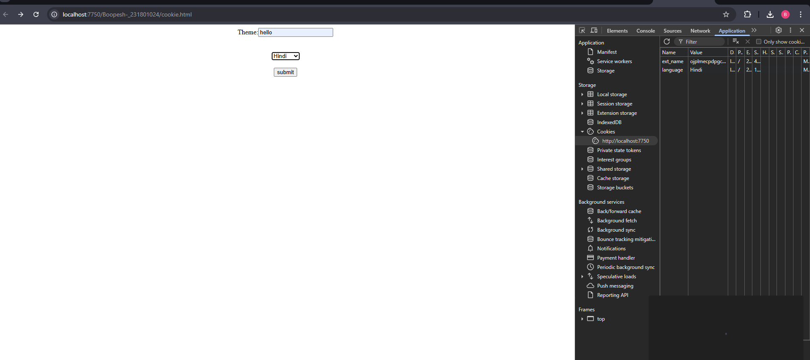

**RESULT:**

Handling user information using cookie is done using servlet successfully.